Software Design and Engineering Enhancement – Contact Service
Brandon Shank
Date: 05/29/2026

Artifact Description
The artifact I worked on for this enhancement is a Contact Service application that I originally built in CS-320. The main purpose of the system is to manage contact records, so users can add, update, look up, and delete contacts. Each contact stores a unique ID, along with a name, phone number, and address.
When I first made this project, it did what it was supposed to do at a basic level, but it didn’t really handle bad input well, and error handling wasn’t very consistent. Because of that, it made sense to use it for this enhancement.

Justification for Inclusion and Enhancements
I picked this project because it already had some important software engineering concepts built into it, such as object-oriented design and unit testing. At the same time, it had several areas that could be improved, which made it a good choice for enhancement. The original version could add, update, retrieve, and delete contacts, but it did not do as much validation as it should have and had limited protection against invalid data.
The enhanced version is organized so that each part of the system has a specific job. The Contact class stores the contact information and makes sure the data is valid before it is saved. The ContactService class manages the contact records and handles actions such as adding, updating, and deleting contacts. Separate JUnit test classes are used to verify that both classes work correctly. Keeping these responsibilities separated makes the code easier to understand and maintain because each class focuses on a single purpose.
For the enhanced version, I focused on making the application more reliable, secure, and easier to maintain. Some of the main improvements include:
- Added stronger validation so fields cannot be blank, exceed length limits, or contain invalid formats. For example, phone numbers must contain exactly ten digits.
- Prevented duplicate contact IDs and made contact IDs immutable after creation.
- Improved error handling by using clear and consistent exception messages.
- Separated validation logic from service logic to improve maintainability.
- Modified the getAllContacts() method so it returns a protected copy instead of exposing the original collection.
- Continued using a HashMap to provide fast contact lookup operations.
- Expanded JUnit testing to cover valid inputs, invalid inputs, and boundary conditions.
One change I made was moving validation into the Contact class. This means the same validation rules are applied whether a contact is created for the first time or updated later. It also reduced repeated code and made it easier to maintain the validation rules in one location.
I also decided to keep contact IDs from being changed after they are created. While this removes some flexibility, it helps keep records consistent because the contact ID acts as the unique identifier for each contact. Since the HashMap uses the contact ID as its key, allowing it to change could create lookup problems and make the data harder to manage.
Another improvement was changing getAllContacts() so it returns a copy that cannot be modified. This limits direct access to the stored collection, but it also helps prevent accidental changes from outside the service class and keeps the data safer.
Overall, these changes made the application more dependable and closer to how a real-world software project would be structured. The system is easier to test, easier to maintain, and better protected against invalid data.

Course Outcomes
This project was really helpful in showing me how to use software design and engineering in a real-world way. The main thing I was trying to do was make the Contact Service application better and more reliable, while also keeping the code neat and easy to work with. To do this, I split up the work between a few different classes, like the Contact class, the ContactService class, and some test classes. This made it easier for me to understand what was going on, test things out, and keep everything running smoothly. By doing it this way, I was able to create a system that's simple to grasp and maintain, which is really important for making sure the application keeps working well over time.
The updates also showed how important it is to make sure data is correct and safe. Now, all contact information is checked before it's stored or updated, which stops wrong data from getting into the system. By making contact IDs unchangeable and giving a copy of the contact list that can't be changed, data is even safer and less likely to be changed by mistake. These changes follow good software engineering habits that focus on making systems reliable, easy to maintain, and secure. They help prevent errors and keep data safe, which is crucial for any system.
One major benefit was that it really helped with testing and making sure the code was good quality. By using JUnit to test more of the code, I could check that everything worked properly, even in unusual situations, which made me more confident that the application would behave as expected. This process also allowed me to take a close look at an existing system, find the weaknesses, and use good software engineering practices to make the design better and more effective overall.

This update shows that I can look at existing software, make useful changes, and use good software engineering habits to help keep it working well and reliably over time.
Reflection
I realized that checking data before it is stored is really important. The original Contact Service application worked for basic contact management, but it did not validate data as thoroughly as it should have. By adding stronger validation and additional test cases, I felt much more confident that the program would behave correctly even when users entered invalid or unexpected information. This helped ensure that the data remained accurate and reduced the chances of errors later in the program.
One of the toughest parts was getting all the validation in one place without affecting functionality that was already working. Every time I updated the validation rules, I had to run the JUnit tests again to make sure valid contacts could still be created while invalid data was rejected. There were several times when one change affected another part of the application, which meant making adjustments and running the tests again. This reinforced how important testing is when modifying existing software.
I also spent time reorganizing the project so the Contact class, ContactService class, and test classes each had a clear responsibility. The individual changes were not difficult on their own, but making sure everything continued to work together correctly required extra testing and verification. Going through that process helped me better understand why separation of responsibilities is important in larger software projects.
I learned that software design often involves tradeoffs. For example, I decided to make the contact ID immutable after it is created. This reduces flexibility because the ID cannot be changed later, but it helps keep records consistent since the contact ID acts as the unique identifier throughout the application. I also modified the getAllContacts() method so outside code cannot directly modify the stored collection. While this limits access, it helps protect the application's data and keeps responsibility for managing records inside the service layer.
Overall, this project helped me better understand validation, testing, and software organization. It showed me that improving an existing application can sometimes be more challenging than creating one from scratch because every change must be tested to ensure it does not affect existing functionality. The experience gave me a better understanding of how software is maintained, improved, and supported over time.

Evidence (Screenshots)
Figure 1: Build Success
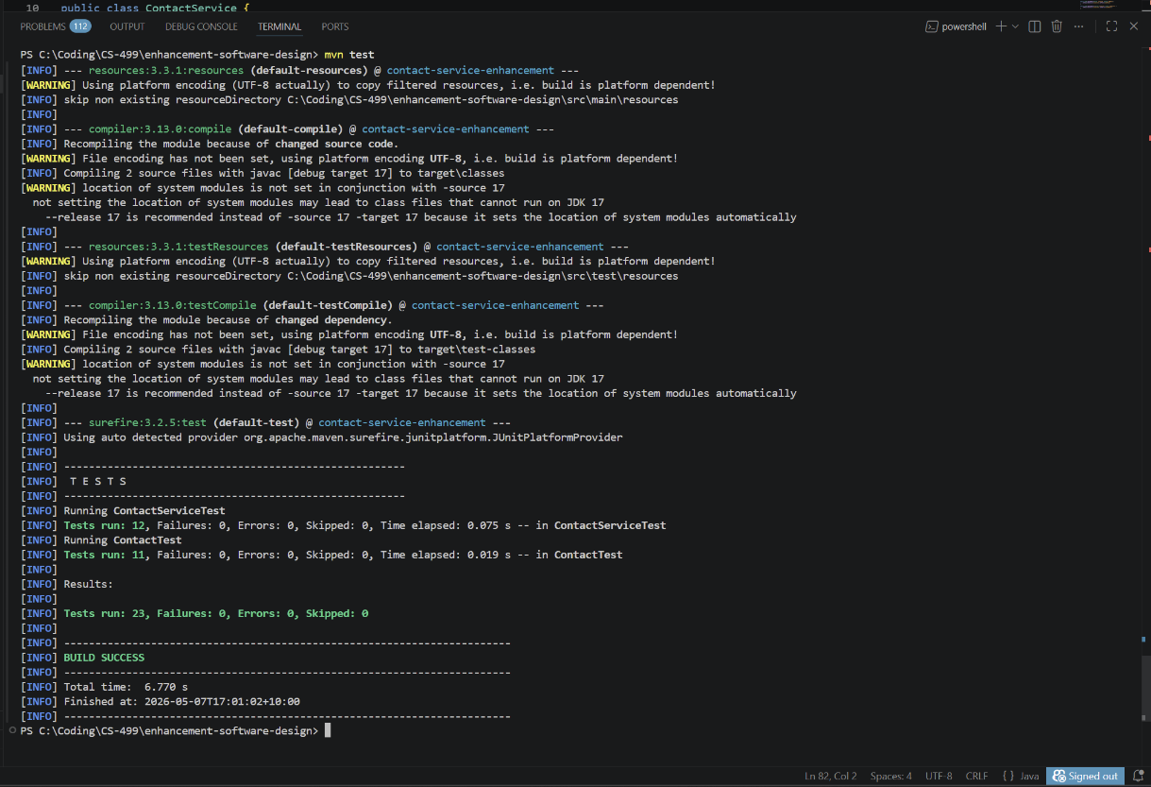
Maven build output showing successful compilation and execution of all unit tests with zero failures, confirming the correctness and stability of the enhanced system.

Figure 2: Tests Running
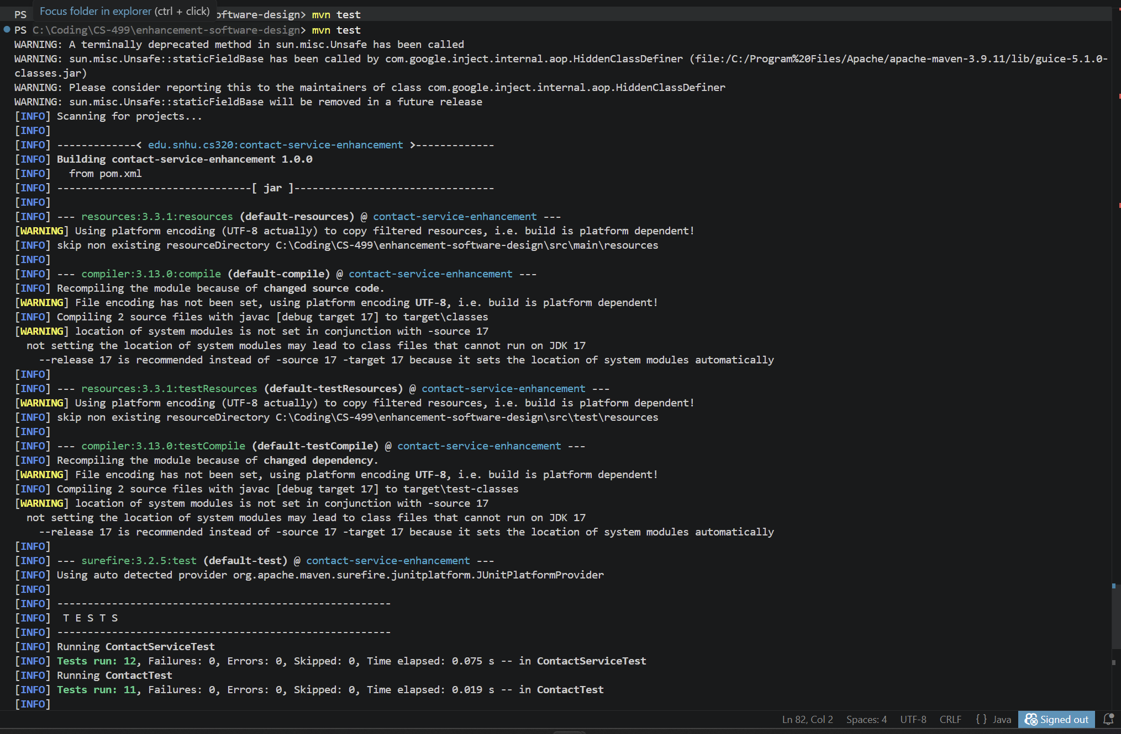
JUnit test execution validating system functionality, including positive, negative, and edge case scenarios to ensure reliability and correctness.

Figure 3: Service Code
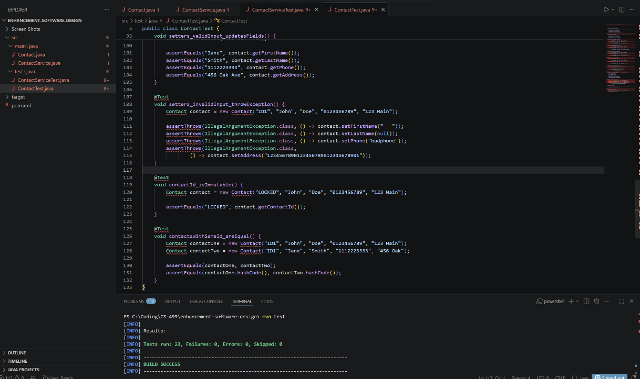
ContactService class implementation demonstrating business logic separation, duplicate ID prevention, and controlled data access through an internal HashMap.

Figure 4: Validation Code 1
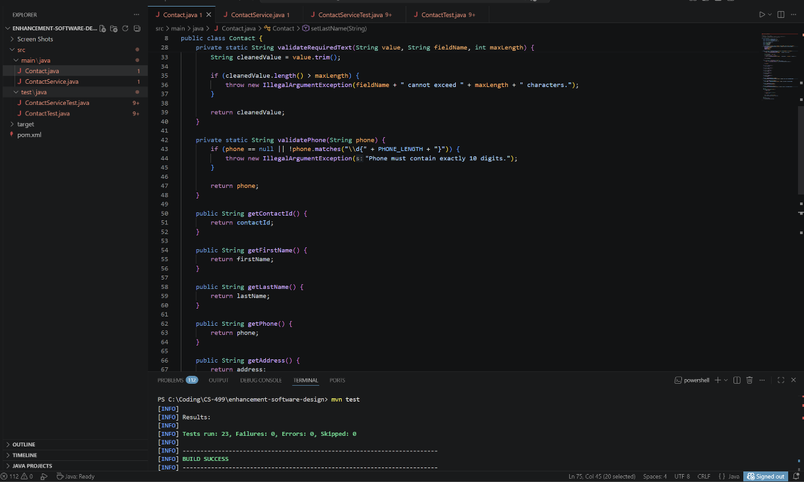
Centralized validation logic ensuring required fields are not null, blank, or exceeding defined length constraints, improving data integrity and security.

Figure 5: Validation Code 2
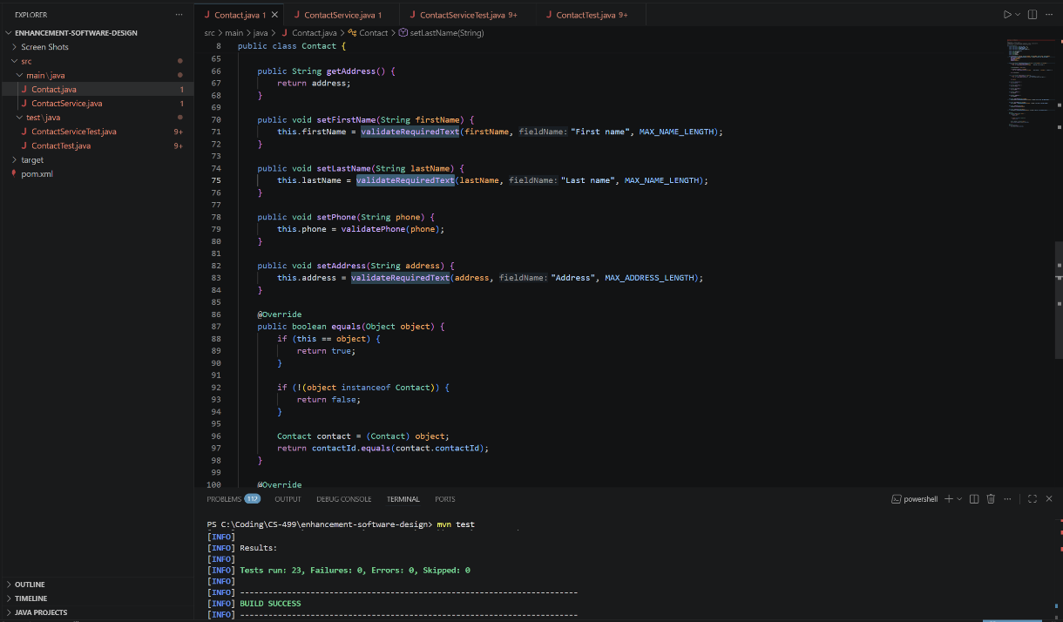
Phone number validation enforcing strict formatting rules (exactly 10 digits), preventing invalid or unsafe input from being processed.

Figure 6: Validation Code 3
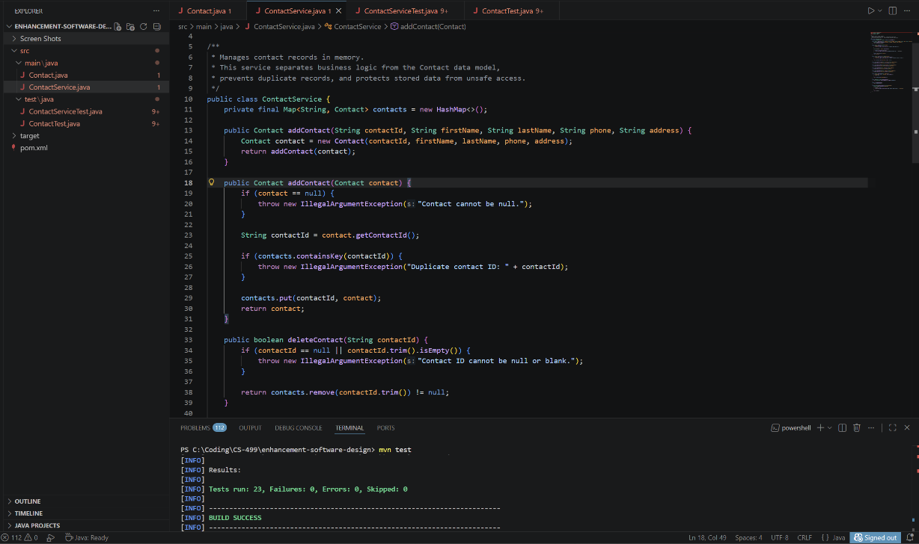
Setter methods applying validation rules before updating object state, ensuring all modifications maintain system constraints.
Figure 7: Validation Code 4
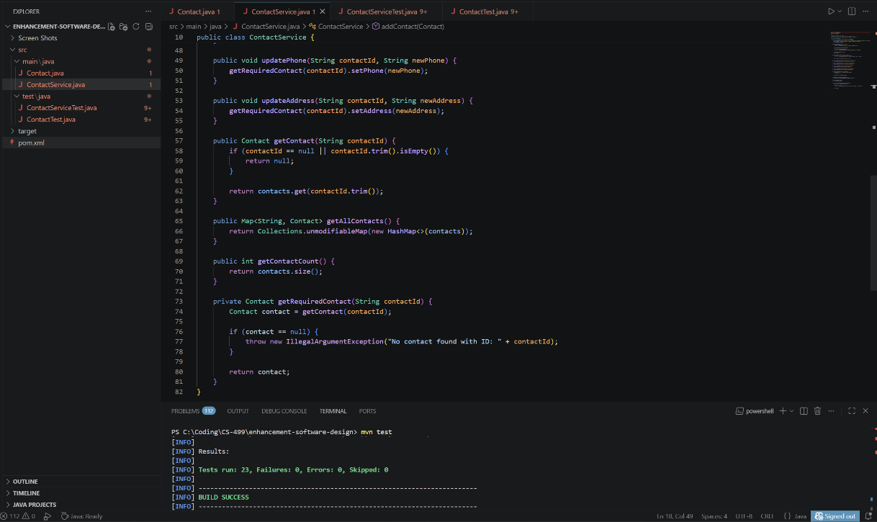
Equality and hashCode implementation based on immutable contact ID, ensuring consistent identity management and preventing logical duplication.

